Ao Li – 798657

Zheping Liu – 683781

Kuan Qian – 686464

Sheng Wu – 814626

Lilian Chan – 858568

Final Project Management Plan

myFarmXchange Case Study

Team Superstars

S1 2017

# Executive Summary

Wilma Flint and Barnaby Rubble, the founders of myFarmXchange, plan to create a social media-style platform where farmers can connect with one another and record diary entries of their farm activities. Their vision is to invoke rural community spirit by increasing the connections within the community, and to help the farmers' economic growth in their agricultural business.

Team Superstars has been employed to help develop this system, given the budget of $50,000 and the timeframe between April to October. Considerations were given into the key functional, operational and technical requirements of the platform as extracted from the clients. An Agile Scrum method was implemented by the team, whereby tasks were allocated to members through short Sprints. The agile software development lifecycle can ensure that the project is well managed and is flexible for changes that may occur throughout the development lifecycle.

The progress of the team was measured through frequent performance reviews, creation of Burndown and Burnup charts, calculating Team Velocity and monitoring scope creep.

Contents

Executive Summary 1

1. Introduction 3

2. Project Management Plan (PMP) 4

2.1 Envision Phase 5

2.2 Speculate Phase 5

2.3 Explore Phase 5

2.4 Adapt Phase 6

2.5 Close Phase 6

2.6 PMP Board 6

2.7 Project Management Task List 7

2.8 PMP Team Velocity 9

3. Narrative Overview 12

3.1 Design Problems 12

3.2 Groomed Product Backlog 12

3.3 Scope of Proposed Solution 14

3.4 Initial List of Stakeholders 14

4. Solution Overview 15

4.1 Sprint Backlog 16

4.2 Features Developed in Sprints 20

5. Software Development Life Cycle 21

5.1 SDLC First Sprint 21

5.2 Visual Representation of SDLC Tasks 24

5.3 SDLC Team Velocity 25

5.4 Scope Creep 26

6. Summary 27

7. References 28

Appendix A 29

Appendix B 36

# Introduction

This document is Team Superstars' Draft Project Management Plan for the myFarmXchange Case Study project. The intended audience for this document are the team members and project supervisors. This document should be read in conjunction with the PMP and SDLC boards created on Trello and the Case Study documentation available on LMS. Revisions on this document may be made in the future.

Team Superstars has been assigned the task of creating a social network platform targeted at farmers which could be released in time for the start of the harvest season in October. The clients are Wilma Flint and Barnaby Rubble, who are wheat farmers and technology enthusiasts and the founders of the small start-up company, myFarmXchange. They have a vision for the platform to enable farmers to form unified trading blocs, to connect users together and improve farmer community connections, and to increase prosperity in the agricultural industry from more efficient selling of crops. Ideally, the platform will also be user-friendly and extendable, making it a potentially valuable and long-lasting economic investment with opportunities for future developments.

Some of the functional requirements of the platform include features to allow users to register and create accounts, connect with one another, create 'diary entries', comment on them and send 'congrats'. The system will also allow users to create events and invite others to attend them. Additionally, there will be options to automatically sync account data across various mobile devices and platforms.

Owing to the many practical agricultural-related uses offered by the platform, its focus on social connections and useability, it is predicted that the platform will build up loyalty within Australian farmers and rise to prominence in the market. The clients have some available funds from their $50,000 Rural Infrastructure Fund grant, and there may be opportunities to earn revenue from the platform in the future.

# Project Management Plan (PMP)

The length of the project spans from the start time in April to the scheduled release date in October. From the initial vision to the final product delivery, the project will follow the typical agile project management framework as discussed by (Chandana, 2012). This includes the ‘envision’ phase, iteration across the ‘speculate’, ‘explore’ and ‘adapt’ phases, where features are progressively completed, and finally the ‘close’ phase after development of the final product. This is as pictured in Figure 1.

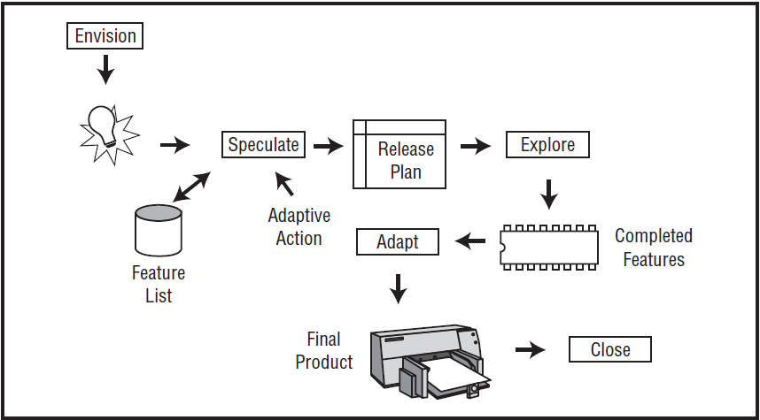

Figure : Image showing the agile project management framework (Highsmith, 2009)

Planning and management of the project is performed through use of the ‘PMP’ board, which can be accessed on Trello. This board contains the cards of the high-level, ‘epic’ project management tasks required up until the ‘explore’ phase of the project. Currently, one Sprint of four weeks has been completed, incorporating the ‘speculate’ phase. The length of the Sprint was decided based on the standards addressed by (Haughton, 2011), which finds the right balance between productivity, momentum and measurability. Owing to consideration of a relatively inexperienced student team, a Sprint longer than the de facto standard of two weeks was chosen. This will alleviate stresses on the team and give them more time to arrange meetings, implement challenging tasks and review work. The reduction of inconvenient breaks in workflow will promote higher team productivity. As more tasks can be completed in the longer period of time, progress will be more measureable and can be more accurately monitored.

To reduce the risk of procrastination brought about by the long Sprint, the team plans to implement and control the project through regular weekly team meetings, where formal minutes are recorded. Informal stand-up meetings are also to be arranged on an irregular basis. The frequency of these meetings ensure that progress is constantly tracked and problems are identified early. Members will be given the opportunity to raise any concerns that were encountered in the tasks they were undertaking. Another advantage of the numerous team meetings is that it helps promote positive team collaboration, communication and bonding, so that the group’s performance and efficiency as a single unit is maximised.

At the end of each Sprint, activities of the previous Sprint are to be reviewed. Burnup and Burndown Charts are created, so that the Scrum Master can monitor the team velocity and make adjustments to future plans. Upcoming tasks are then agreed upon and distributed to each member.

## 2.1 Envision Phase

During the envision phase, the foundations of the project are developed. The team builds a clear understanding of the product that needs to be produced and how that can be achieved (Highsmith, 2009). Considerations need to be made about the client’s product vision, the scope of the project, constraints that may be encountered, and the business case. The project community and stakeholders are determined, and the risk register developed. Finally, the team’s approach on how to approach the project is discussed and agreed upon. This includes establishing the team norms, member’s individual roles, collaboration tools used and working style. As new information is obtained, the vision of the product may change accordingly.

This phase was accomplished by Team Superstars in a single ‘kickoff’ week before the start of the speculate phase Sprint, as is typical of a small project (Highsmith, 2009).

## 2.2 Speculate Phase

The primary purpose of the speculate phase is for the development team to identify the features that need to be implemented in the current Sprint. The product vision from the envision phase is transformed into a backlog of requirements (Chandana, 2012). The team also considers the high level tasks required in order to meet the requirements, in the form of product features. These are then prioritised so that the order in which they are developed can be determined. Each feature is broken down into manageable ‘user stories’ so that the team can estimate the effort required for each task. Once this is known, a feature-based delivery plan including the schedule and resource allocations can be released. Milestones, releases and iterations are all incorporated within the delivery plan. Risk mitigation strategies are considered and incorporated into the plan, to ensure the delivery of the vision.

In the current project, the team has completed the tasks within the speculate phase in a single Sprint. The team then created Burndown and Burnup Chart to monitor team velocity and scope creep.

## 2.3 Explore Phase

Planned features are developed, tested and delivered during the explore phase. Workloads need to be monitored and well-managed using risk mitigation strategies that were developed previously. Various alternatives that can be used to implement and fulfil the requirements of the project are considered.

Every member within the team is responsible for harbouring a collaborative and self-organizing project community to ensure that work is done efficiently. This includes attending stand-up meetings, interacting with one another and performing peer reviews. The team also needs to manage the interactions with the clients, product management and other stakeholders (Highsmith, 2009). The Burndown and Burnup Charts for the SDLC Sprint is drawn in this phase to monitor team performance during the feature development.

## 2.4 Adapt Phase

In the adapt phase, the team reviews what has been achieved, the delivered results and the team performance. The results are compared with the original plan and any problems are identified. The team discusses on changes that will improve the performance in the next Sprint. Current plans can then be modified as necessary to adapt to the changes. Some adjustments that might need to be made include changes of features, modifying effort estimations and changing processes (Alnaqaa, 2013).

The team will often review the product and newly developed features with the client. This would typically involve demonstration of the feature to the client. In doing so, it can be confirmed if the product is working as is expected by the client and the business benefits can be validated.

## 2.5 Close Phase

Being the final stage of the agile project management framework, the close phase is to ensure that all deliverables are complete and the end product is considered acceptable by the client. The team concludes the project, records the lessons that were learnt and can celebrate the completion of the project. Team members can then be deployed for other projects.

Tasks in the adapt and close phases has been planned by Team Superstars and they are to be completed in the future.

## 2.6 PMP Board

Team Superstars’ PMP board is as shown in Figure 2. There are three ‘To-Do’ lanes that contain task cards from each of the phases to show things that are planned and need to be done in the future. Items in the ‘Doing’ lane are tasks that are currently being undertaken by a team member who has assigned themselves as a resource of that particular task. Tasks in the ‘Done’ lane are items that have been completed and confirmed by the whole team.

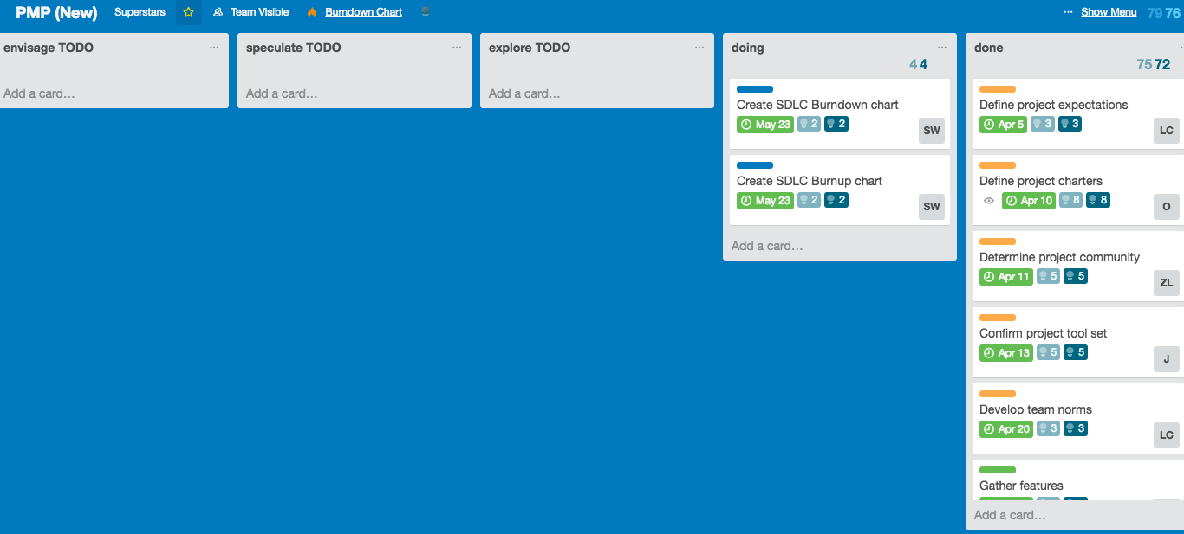

Figure : PMP board of Team Superstars created on Trello.

The tasks contain some due dates to remind members of certain deadlines which were ascertained from functional dependencies between the cards. Each card has been colour-coded to indicate the original phase that it was in. Orange represents ‘envision’ phase, green represents ‘speculate’ phase, and blue represents ‘explore’ phase.

Each task card represents an ‘epic’ user story. These are also listed in the PM task list below and further broken down into ‘just-in-time’ PM tasks.

The effort of each task was estimated using the story point format, which is influenced by the amount of work, complexity, risk and uncertainty involved (Cohn, 2016). The user stories are compared with one another and values are assigned relatively. Through experiences from previous projects, it was found that the use of Fibonacci numbers to represent the effort was particularly effective (Waters, 2007). This method is employed in the current example. Agreement is reached among the team regarding the effort of a particular user story that can be related to by everyone, which is then used as a comparison point to all other user stories.

For the project management task list, the story points used for the decomposed ‘just-in-time’ tasks were 1, 3 and 5. Story point estimates can also give some indication of the time required for achieving tasks.

* 1 story point: basic, straightforward task that is easily understood and achieved
* 2 story points: a task that requires a small amount of research
* 3 story points: task that requires some careful analysis, planning and consideration
* 5 story points: task that requires extensive research and consideration of multiple factors and uncertainties

## 2.7 Project Management Task List

1. At Envision Phase, I want to define the project expectations.
   1. Client meeting #1 (3 SP)
   2. Record survey from clients (1 SP)
   3. Confirm budget (1 SP)
   4. Confirm expected delivery date (1 SP)
2. At Envision Phase, I want to define the project charters.
   1. Review case study documentation and survey from clients. (3 SP)
   2. Set boundaries for the project. (3 SP)
   3. Develop the product vision. (3 SP)
   4. Determine the target customers and benefits. (3 SP)
3. At Envision Phase, I want to determine the project community.
   1. Client meeting #2 (3 SP)
   2. Record survey from clients (1 SP)
   3. Define the stakeholders (1 SP)
   4. Nominate the scrum master and the level of authority given (1 SP)
   5. Recruit team members (1 SP)
   6. Push information out to the team (1 SP)
4. At Envision Phase, I want to confirm the project tool set.
   1. Team meeting #1 (3 SP)
   2. Create minutes (1 SP)
   3. Establish communication tools between the scrum master and stakeholders (3 SP)
   4. Establish collaboration tools among the team members (1 SP)
5. At Envision Phase, I want to develop the team norms.
   1. Continuation of Team meeting #1
   2. Create minutes
   3. Establish team norms (1 SP)
   4. Decide on risk register (3 SP)
6. At Speculate Phase, I want to gather features.
   1. Analyse case study (5 SP)
   2. Client meeting #4 (3 SP)
   3. Record survey from clients (1 SP)
7. At Speculate Phase, I want to create the product backlog.
   1. Team meeting #2 (3 SP)
   2. Create minutes (1 SP)
   3. Define the desired features (epic user stories) (5 SP)
   4. Estimate the effort and assign story points (3 SP)
8. At Speculate Phase, I want to groom the product backlog.
   1. Team meeting #3 (3 SP)
   2. Create minutes (1 SP)
   3. Review survey from the clients (1 SP)
   4. Evaluate and rank features (3 SP)
9. At Speculate Phase, I want to plan features to be released.
   1. Team meeting #4 (3 SP)
   2. Create minutes (1 SP)
   3. Review business objectives (1 SP)
   4. Select features to be released and provide reasoning (2 SP)
   5. Create Sprint backlog (user stories) (5 SP)
10. At Speculate Phase, I want to create the iteration, milestone and release plan.
    1. Team meeting #5 (3 SP)
    2. Create minutes (1 SP)
    3. Verify accuracy of effort estimates (3 SP)
    4. Plan feature completion dates (3 SP)
    5. Plan feature implementation dates (1 SP)
11. At Speculate Phase, I want to incorporate risk mitigation strategies.
    1. Continuation of team meeting #5
    2. Create minutes
    3. Document risks by feature (3 SP)
12. At Speculate Phase, I want to create the PMP Burndown Chart.
    1. Review effort estimations (3 SP)
    2. Monitor team velocity (1 SP)
13. At Speculate Phase, I want to create the PMP Burnup Chart.
    1. Review effort estimations (3 SP)
    2. Predict team velocity (1 SP)
    3. Monitor scope creep (1 SP)
14. At Explore Phase, I want to reduce the risks and uncertainties.
    1. Take note of issues and roadblocks (1 SP)
    2. Discuss risks and seek to reduce them (3 SP)
    3. Track progress on feature board (1 SP)
    4. Make adjustments to plans (3 SP)
15. At Explore Phase, I want to test features.
    1. Ensure features are tested (3 SP)
    2. Check that requirements are met (1 SP)
16. At Explore Phase, I want to create the SDLC Burndown Chart.
    1. Review effort estimations (3 SP)
    2. Monitor team velocity (1 SP)
17. At Explore Phase, I want to create the SDLC Burnup Chart.
    1. Review effort estimations (3 SP)
    2. Predict team velocity (1 SP)
    3. Monitor scope creep (1 SP)
18. At Adapt Phase, I want to review the delivered features.
    1. Compare delivery results with the original plan (3 SP)
    2. Discuss the strong and weak points of the delivered product (3 SP)
19. At Adapt Phase, I want to review the product with the client.
    1. Client meeting #5 (3 SP)
    2. Validate business benefits (3 SP)
20. At Adapt Phase, I want to review team performance.
    1. Team meeting #6 (3 SP)
    2. Create minutes (1 SP)
    3. Evaluate progress (3 SP)
21. At Adapt Phase, I want to adjust plans.
    1. Add or remove features (3 SP)
    2. Edit effort estimations (3 SP)
    3. Modify development processes (3 SP)
    4. Adjust team velocity (3 SP)
    5. Review or change team members (3 SP)
    6. Update the list of risks (3 SP)
22. At Close Phase, I want to ensure that the deliverables are completed.
    1. Client meeting #6 (3 SP)
23. At Close Phase, I want to ensure that the business objectives have been achieved.
24. At Close Phase, I want to review overall performance.
    1. Record the lessons learnt (3 SP)

The complexities and effort required to complete the ‘epic’ user stories were then discussed about and agreed upon by the team. Considerations were made regarding the story points of the low-level user stories that made up the ‘epic’. Then the stories were ranked on the Fibonacci scale of 1, 2, 3, 5, 8 and 13.

## 2.8 PMP Team Velocity

A Burndown Chart is a common Sprint tracking mechanism used by Agile teams (Mittal, 2013). Sometimes they are created using task count and other times, they are plotted using story points. In this project, the story point estimates for each task card on the PMP board were used to calculate a high-level estimate of the length of each Sprint. This is visually displayed in the Burndown Chart in Figure 3.

On the y-axis, the story points (or effort remaining) is shown, while on the x-axis is the time in days. As can be interpreted from the chart, Team Superstars’ can be expected to complete the 52 story points in the PM Sprint within 20 days (or 4 weeks).

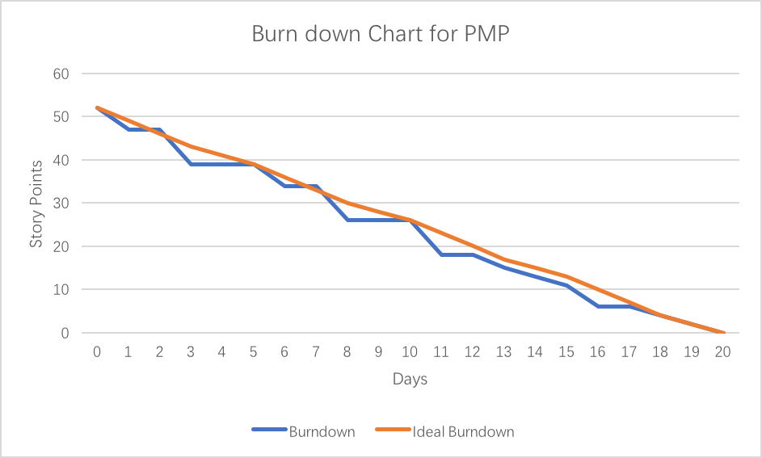

Figure : Team Superstars’ PMP Sprint progress as represented on a Burndown Chart.

After completion of the task cards, the team discussed a more accurate measure of the actual effort required by the activities and recorded this on the cards. This was also used to measure the progress of the Sprint by creating a Burnup Chart, as shown in Figure 4.

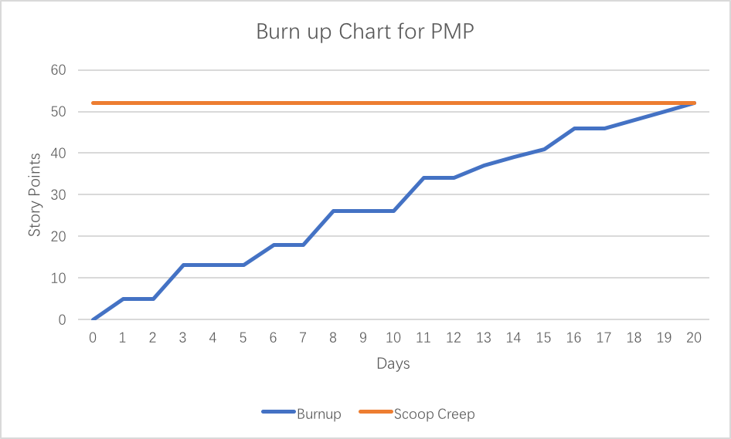

Figure : Team Superstars’ Sprint progress as represented on a Burnup Chart.

The velocity of an agile development team is a measure describing the amount of work the team can complete in the duration of a single Sprint. It can be calculated at the end of Sprints by totalling all the story points of the user stories that were completed.

The team velocity of Team Superstars during the PM Sprint were found to be as follows:

**Week 1**: 13 story points/week

**Week 2**: 13 story points/week

**Week 3**: 15 story points/week

**Week 4**: 11 story points/week

This shows a relatively consistent velocity throughout the course of the project, meaning that the workload was managed quite well. Additionally, there was no evidence of Scope Creep. The average velocity over the four weeks was 13 story points each week, which will be used as a basis for managing the SDLC Sprints.

# Narrative Overview

The design problem currently presented to the development team is to plan, build and implement a social media platform with a farming theme. The clients aim to enable farmers to form unified trading blocs through this application, simultaneously improving farmer economic prosperity and farmer community connections. It will be a tool targeted towards farmers and other interested parties, offering services to help monitor national grain price fluctuations, analyse the market and track performance within farms. The platform will be developed with the view of possible future enhancements. The clients aim to earn revenue from the application when it becomes prominent in markets.

## 3.1 Design Problems

The most crucial problem in this project is the need to ensure the product would become popular in the market. The vision for the platform is innovative, aiming to combine farming functionalities with social media services similar to those provided by Facebook. Therefore, it is imperative to perform some market research first to find out what services farmers want from the product and to keep in touch with them so they can be notified when the product becomes available in the market. This may be in the form of performing surveys, case studies, allowing farmers to register their interest and leave personal details, or advertising the product. In comparison to other social media platforms like Facebook or Twitter, myFarmXchange has an additional requirement of needing to control access so that only farmers with valid NGR numbers can post content to the platform.

Another issue is that the clients are not so experienced in developing this type of service. To mitigate this problem, an experienced Product Manager is needed.

The targeted users, which are farmers, also do not generally have strong technical backgrounds, so the product must be easy to use. Frequently performed actions should be executable in a straightforward way with minimal procedures required. In order for this to be realised, user interface of the service needs to be carefully designed. A web interface (i.e. website) needs to be implemented for maximum user coverage and instant access, while it is still desirable that mobile applications are also built for better experience on specific mobile platforms, such as Android and iOS.

## 3.2 Groomed Product Backlog

The key requirements that were gathered from client meetings and virtual client discussions are as documented in the Product Backlog. The order in which the items are listed is indicative of the priority of the feature.

1) As an active user, I want to create diary entries to record farm indicators/activities, so that I can track performance/improvement. (8 SP)

2) As a general user (observer or farmer), I want to create an account and profile so that I can access the platform from various devices. (5 SP)

3) As an active user, I want to have search and connect functions between users, so that I am able to connect with other farmers sharing the same interest in crops. (3 SP)

4) As an active user, I want to send comments and ‘congrats’ to other users, so that I can build community connections and we can support one another. (3 SP)

5) As an active user, I want to create events and invite my connections to attend so that farmers can increase revenue in selling grains and share knowledge. (3 SP)

6) As an active user, I want to sync the platform with other mobile devices such as weather stations and fitness tracking, so that more data can be easily recorded. (2 SP)

7) As an active user, I want to sync the platform with other existing farm services, so that it is convenient and more users will be attracted to start using it. (2 SP)

8) As a general user, I want to be able to run the platform on all versions of Windows starting from Windows 7 (Non-functional - usability). (2 SP)

9) As a general user, I want to be able to run the platform on all types of browsers, including Firefox, Chrome and Safari, so that I can use the platform with any kind of browser (Non-functional - usability). (2 SP)

10) As a general user, I want the platform to look similar on both web browsers and mobile devices, so that it looks familiar to me. (Non-functional - usability). (2 SP)

11) As an administrator, I want the platform to be easy to restart whenever it crashes, so that it can provide stable service. (Non-functional - reliability). (2 SP)

12) As a general user, I want the site to be available when I am attempting to access it, so that I don’t get frustrated and find another product to use (Non-functional - availability). (2 SP)

13) As an administrator, I want our platform to support different human languages, so that users who speak different languages can use the platform (Non-functional - performance). (2 SP)

14) As a general user, I want the validation on the login page to be very clear, so that I can easily see when/if I make a mistake when I log in (Non-functional - security). (2 SP)

15) As an administrator, I want our platform to validate active users before giving them an account, so that malicious attacks on the platform can be avoided (Non-function - security). (2 SP)

16) As an administrator, I want our platform to have some load tests, so that we can be aware of the maximum load capacity of our platform (Non-functional – scalability). (2 SP)

17) As an administrator, I want our platform to have some security mechanisms, so that users’ privacy can be protected in the future when “eBay-style” transaction processing features are introduced (Non-functional – security). (2 SP)

18) As an administrator, I want the platform to automatically switch between backup databases, so that it can easily use a different database whenever problems take place with one database. (Non-functional - availability). (2 SP)

19) As an administrator, I want the platform to use multiple repeated databases rather than just one, so that we can keep availability whenever one database crashes (Non-functional - reliability). (2 SP)

20) As an administrator, I want our databases to be built in regions where there are many users, so that the platform performance speed is maximised and data is returned quickly to the majority of users (Non-functional – performance). (2 SP)

In assigning the story points, consideration was given into client priority, amount of work to be completed, complexity of the tasks and uncertainties involved. Although the estimates do not necessarily have to be accurate, they need to be consistent (CA Technologies, 2017). Inaccuracies in estimates could then be corrected from the calculated Sprint velocities.

## 3.3 Scope of Proposed Solution

Several high-level tasks were identified as part of the proposed scope of a solution to meet the basic requirements of the design problems.

* A website will be built and maintained to allow users access to the platform from their computers. On mobile devices, they can gain access through either a website browser or the application designed for their operating system.
* Both the website and the mobile app are to be created based on the structure of a social media site, including all the functions stated in the requirements. Any additional functionality should be expanded to the original platform easily.
* A database is to be set up to store all information that is needed and generated by this platform.
* The system is to be made to support various external data sources, with built-in data adapters to support common farm measurement devices and other mobile farm services. Investigation needs to be made to the interfaces provided by those services and devices, so that data can be imported correctly from those sources.

## 3.4 Initial List of Stakeholders

1. *The development team* is a group of 5 relatively inexperienced software engineers. The team has experience in Java programming and databases.
2. *The clients* are Wilma Flint and Barnaby Rubble, founders of myFarmXchange who are wheat farmers and technology enthusiasts.
3. *Farmers* who want to connect to other farmers within the community and share their activities.
4. *The local council* who may share the interest of improving the farming communities’ prosperity and connections. They may seek to invest in the platform.
5. *Other technology enthusiasts* who are interested in the agricultural industry and social media platforms.

# Solution Overview

There are several main targets in the current project.

* Apps are to be built for major mobile operating systems such as Android and iOS, so that users can access the service with their mobile devices conveniently. In order for the user to access the service on their computers, a website needs to be built, set up, and maintained. The website can be designed to support mobile devices as well, in the case where the mobile app is not available to a user.
* Both the website and the mobile apps are to be created on the basis of a social media site with the functions to connect users, send comments and 'congrats'. This differentiates the application from other existing farm services and helps promote farmer communities’ connections. The software should also be designed for high usability, so that the service is easily accessible for people of all backgrounds and ages, especially for farmers with little to no technical background. It is required that functions to make and attend events are implemented, helping to promote farmer grain sales and improving economic prosperity. Additionally, farmers should be allowed to share their experiences at these events, further promoting connections and facilitating sharing of expertise. Functions to create diary entries about farm activities are to be implemented, which can help farmers monitor their own performance and track improvements. There will also be an algorithm deriving estimated cost of farm activities using the activity type, duration, location and markets.
* A database is to be set up to store user profile information, dairy entries and other posts, so that such inputs from the user can be stored persistently. A database will be deployed on a server with an interface provided for access from the applications and the website. This allows the user to always see the latest updates on any of their devices, and to make changes that are instantly available to others. The database is to be designed in a way so that future changes can be relatively easily applied, and optional fields are well supported.
* The system will be made to support external data sources with adapters being built for data import from common farm measurement devices and farm services. This will save users the time it takes to migrate their data manually, and provides them a unified place for all their farm data. Investigation needs to be made to the interfaces provided by the services and devices, so that data can be imported from those sources.

Figure 5 shows an image of the overall system architecture of the proposed solution.

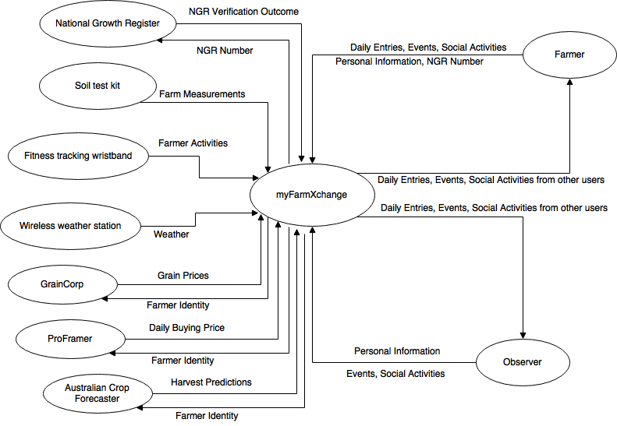

Figure : Image showing the proposed solution for myFarmXchange platform

Some features that were perceived to contribute to achieving the desired requirements were chosen and listed as ‘epic’, high-level user stories in the Sprint Backlog, as shown below.

## 4.1 Sprint Backlog

1) As an active user, I want to add harvest task activities into my diary, so that I can track my harvest tasks to improve performance.

2) As an active user, I want to add start time, end time and duration to all my entries, so that I can record the time accurately.

3) As an active user, I want to see the cost estimation based on the location and market on the platform, so that I can perform my cost management more conveniently.

4) As an active user, I want to add crop type, quantity and quality to my harvesting activity entries, so I can display more details to other users.

5) As an active user, I want to see my official ‘harvest grain quality’ ranking for my diary, so that I can compare my grain quality to others.

6) As an active user, I want to add a selling task activity into my diary, so that I can improve my economic prosperity in selling grain.

7) As an active user, I want to add storage task activities into my diary, so that statistics about good storage reasons can be concluded from my grain storage records.

8) As an active user, I want to add a maintenance task activity into my diary, so that I can improve the quality of grain.

9) As an active user, I want to add an equipment upgrade activity into my diary, so that I can help others know the effect of the equipment upgrade.

10) As an active user, sometimes I want to upload some map data of my farm paddock in a standard GPS file format (tcx or gpx), so that I can clearly tell others about the location of my farm.

11) As an active user, I want to add entries for concrete farm measurements, so that I can measure my farm performance.

12) As an active user, I want to add date, cost estimation and unit of measure to my concrete farm measurements, so that I can display more details to other users.

13) As an active user, I want to add entries for indirect measures, so that I can foster productivity innovations.

14) As an active user, I want to add date, type of measure and cost estimation to my indirect farm measurements, so that I can display more details to other users.

15) As an active user, I want to add text-based diary entries, so that I can write comments about how I am doing against my goals.

16) As an active user, I want to attach photos and videos, so that I can share some real photos of the farm and videos of farm activities with my friends.

17) As an active user, I want to add comments about how I performed against my goals or some other piece of information, so that I can share with my friends.

18) As an active user, I want to be able to post comments on other users’ entries, so that the platform can be like other social media sites like Facebook.

19) As an active user, I want to be able to create diary entries to record farm indicators/activities, so that I can track performance/improvement of my farm.

20) As an active user, I want to be able to delete my activity entries, so that I can manage my posts.

21) As an active user, I want to edit my activity entries, so that I can update or change the information posted.

22) As an administrator, I need to ensure that entries added by active users from different devices are stored in the same database, so that there will not be mismatching entries on different platforms.

23) As an administrator, I need to maintain several different data entries that were recorded for different types of activities, so that it will improve user experience and attract more users to use it.

24) As an administrator, I want to ensure that users store a date, start time and duration in every activity, so that we can track and give some statistics about averages to users.

25) As an administrator, I want to ensure users store an estimate of the cost of the activity based on the activity type and duration, so that we can track and give some statistics about averages to users.

26) As an administrator, I want to ensure users store crop type, quantity and quality for each farm activity, so that we can track and give some statistics about averages to users.

27) As an administrator, I need to store map data of the farm paddock in a standard GPS file format, so that the map data can be shared to other users.

28) As an administrator, I want to ensure users store cost estimates, dates and units of measure for their concrete farm measurements, so that it is ensured users entered concrete measurements.

29) As an administrator, I want to ensure users store dates, types of measure and cost estimations for indirect measures, so that it is ensured users can create objective indirect measurements.

30) As an administrator, I need to manage the storage of text-based diaries of different lengths, uploaded by users, so that users can upload various lengths of text-based diary.

31) As an administrator, I need to store photos and videos that users upload, so that users can share them with others.

32) As an administrator, I need to manage the storage of different lengths of comments uploaded by users, so that users can upload various lengths of comments.

33) As a user, I want to register as either an active member or an observer, so that I can log into the platform.

34) As an active user, I want to provide my official National Growers Registration (NGR) number, so that my identity can be confirmed in the platform.

35) As a user, I want to provide a range of farm and demographic information such as age, gender, location, crop, farm size and specify some productivity goals, so that it would let others know about me from the profile.

36) As a user, I want to add a profile picture, so that others can see what I look like.

37) As a user, I want to sync the platform to accept imported data from other external sources, so that the diary entries for activities or measurements captured by other devices can show on the platform.

38) As a user, I want only supported data to be imported from other mobile devices that myFarmXchange platform supports during syncing, so that the platform can help filter unwanted data.

39) As a user, I want to sync the data from other farm platforms such as GrinCorp, ProFarmer and Australian Crop Forecaster, so that I can get information about selling grains online, daily variations in the buying price and harvest predictions based on weather conditions, on the platform.

40) As a user, I want only supported data to be imported from other existing farm services that myFarmXchange platform supports during syncing, so that the platform can help me filter the data I don't want.

41) As an administrator, I want to ensure users set up a link to the services they want to sync, so that we can ensure activities are synced to their diary automatically.

42) As a user, I want to search for people based on their locations or our shared interests in crops, so that I can send "connection" requests to them.

43) As a user, I want to accept/decline connection requests from other people, so that I can manage my friends circle.

44) As a user, I want the functionality to disconnect with people, so that I can manage my friend circle.

45) As a user, I want to report anti-social behaviour, so that users who violate the Code of Conduct can be removed by the platform administrator.

46) As an administrator, I want to track users' reports so that I can check the validity of these reports.

47) As a user, I want to see my connected friends' diary entries so that I can comment on or send "congrats" to those entries.

48) As an active user, I want to create events with date, time and location, so that I can send invitations to connected users and improve the sales of my crops at such events.

49) As an active user, I want to be invited to events, so that I can respond with accept, decline or "maybe" and leave comments on events to which I am invited.

50) As a user, I want to be able to run the platform on all versions of Windows from Windows 7 on (non-functional – usability).

51) As a user, I want to be able to run the platform on all types of browsers, including Firefox, Chrome, Safari etc., so that I can use the platform with any browser (non-functional – usability).

52) As a user, I want the platform look similar on different web browsers and mobile devices, so that it’s easy for me to get familiar with it (non-functional – usability).

53) As an administrator, I want the platform to be easy to restart whenever it crashes, so that it's easier to keep persistent service (non-functional – reliability).

54) As a user, I want the site to be available 99.999 percent of the time that I try to access it, so that I don’t get frustrated and find another site to use (non-functional – availability).

55) As an administrator, I want the platform to support different human languages, so that people from all over the world who speaks different languages can use the platform (non-functional – performance).

56) As a user, I want the validation on the login page to be very clear, so that I can easily see when or if I make a mistake when I log in (non-functional–security).

57) As an administrator, I want our platform to validate the active user before giving him or her an account, so that malicious attacks on the platform can be avoided (non-function – security).

58) As an administrator, I want our platform to perform some load tests, so that we can determine the load limits of our platform (non-functional – scalability).

59) As an administrator, I want our platform to have some security mechanisms, so that users’ privacy can be protected in the future when “eBay style” transaction processing facilities become available (non-functional – security).

## 4.2 Features Developed in Sprints

Team Superstars plan to develop all the necessary features for the platform within five SDLC Sprints. The most important features in relation to client priorities and requirements were chosen out of the Sprint Backlog. These were perceived to be most aligned to the business objectives. Having planned the first Sprint, it was determined to contain approximately 23 story points, which was deemed an appropriate workload for a 5 member team in a two week period, with reference to the team velocity from the previous PMP Sprint. The following lists the features that are planned for implementation in each Sprint.

* First Sprint: Product Backlog feature (1)
* Second Sprint: Product Backlog features (2), (6) and (7)
* Third Sprint: Product Backlog features (3), (4) and (5)
* Fourth Sprint: Product Backlog features (8), (9), (10), (11) and (12)
* Fifth Sprint: Product Backlog features (13), (14), (15) and (16)

Remaining, Product Backlog feature (17) was discarded due to time and budget limitations, and will be left as an option for future enhancement. Product Backlog features (18), (19) and (20) were also left out as it is not predicted that there will be many users at the launch of the platform. Multiple databases can be considered after there has been considerable growth in the user based, whereby the revenues gained at that point can be used for system upgrades.

# Software Development Life Cycle

The development model chosen for this project was the Agile Scrum method, which will allow the team to work in a flexible manner. Frequent team meetings and client meetings will allow for regular feedback between the members and clients to ensure that there is a clear understanding about the progress and problems encountered. The agile development model enables easy adjustments to changes in requirements and early detection of problems, so that risks are reduced. Development of the software will be implemented through five sprints, each of two weeks. This was chosen with reference to the de facto industry standards. It is shorter than the PMP Sprint as the team deemed it necessary to review work more frequently, due to team member inexperience in the development processes. During each of these Sprints, chunks of working software will be developed relating to some of the identified desired features, as explained in the previous section. The team plans to manage and control the project through weekly team meetings which would allow members to raise any concerns encountered and give a report about their progress.

## 5.1 SDLC First Sprint

Team Superstars has planned and is about to implement the first software development life cycle Sprint, wherein Product Backlog feature (1) is to be developed. This feature was chosen to be developed first as it is considered the core function on top of which other features are built on. This item can be considered as a combination of 12 specific features:

1. As an active user, I want to add harvest task activities into my diary, so that I can track the activities and improve my farm’s performance. (3 SP)
2. As an active user, I want to add a selling task activity into my diary, so that I can improve my economic prosperity in selling grain. (3 SP)
3. As an active user, I want to add storage task activities into my diary, so that statistics about optimum storage conditions can be concluded from my grain storage records. (3 SP)
4. As an active user, I want to add maintenance task activities into my diary, so that I can improve the quality of my grain. (3 SP)
5. As an active user, I want to add equipment upgrade activities into my diary, so I can let others know about the effects of the new equipment. (3 SP)
6. As an active user, I want to add start times, end times and duration to all my farming activities, so that I can record the periods of each farming activity accurately. (2 SP)
7. As an active user, I want to see average cost estimations for harvest tasks based on my current location and market, so that I can manage costs more conveniently. (2 SP)
8. As an active user, I want to add entries for different types of measures, so that I can foster productivity innovations.
9. As an active user, I want to add text based diary entries, so that I can write comments about how I am performing against my goals.
10. As an active user, I want to add crop type, quantity and quality to my harvesting activity entries, so that I can record more details about my harvest crops. (2 SP)
11. As an active user, I want to see the official ‘harvest grain quality’ ranking of my diary, so that I can compare my grain quality with that of others. (2 SP)
12. As an active user, sometimes I want to upload map data of my farm paddock in a standard GPS file format (tcx or gpx), so that I can clearly tell others about the location of my farm. (2 SP)

The above features can be decomposed into multiple, low-level, ‘just-in-time’ SDLC sprint tasks that are given to the developer. These can be categorized as functions relating to one of the following categories:

For All Entries

* As an active user, I want to find a button or link for new entries at the home page, so that I can quickly start adding entries.
* As an active user, I want to choose between different types of farming activities and measurements, so that I can enter the information I want.
* As an active user, I want to add multiple diary entries at the same time, so that it takes less time when I need to add a lot of entries.
* As an active user, I want my diary entries to be stored in a database, so that people can access it later.
* As an administrator, I want timestamps to be stored in a standard format, displayed accordingly for users in different time zones, so that all users can see the activities posts from themselves and their friends in their local time.

For All Farming Activities

* As an administrator, I want the database to support all farming activities, so that such data can be stored persistently.
* As an active user, I want to add start time and end time to all my activities according to my own local clock, so that I can check and compare the time record of all my harvest activities.
* As an administrator, I want to display the duration of each user's farming activity, so that users can see the time period of each harvest activity.
* As an administrator, I want to calculate the duration of each user's farming activities by utilising the start time and end times that users added into the platform table, so that I can support duration calculation on the platform.
* As an administrator, I want the platform to display cost estimations automatically if it is not provided by the user, so that the platform can help active users perform cost management more conveniently.
* As an administrator, I want to calculate the average cost estimation for all farming activities based on the location and market of the users, so that I can support cost estimation function on the platform.

For Measurements

* As an administrator, I want the database to support measurements, so that such data can be stored persistently.
* As an active user, I want to add date and units of measure to concrete measurements, so that such an entry contains useful information.
* As an active user, I want to add date and type of measure to indirect measurements, so that such an entry contains useful information.

Text Based Entries

* As an administrator, I want the database to support text based entries, so that such data can be stored persistently.
* As an active user, I want to add text to a text based entry, so that I can post my thoughts as words.
* As an active user, I want to add photos and videos to a text based entry, so that the entry reflects my ideas better.

For Harvesting Tasks

* As an administrator, I want the database to support the extra fields for harvesting activities, so that such data can be stored persistently.
* As an active user, I want to add crop type, quantity and quality to my harvesting activities, so that I can have a clear record about the harvest crops.
* As an administrator, I want to show the official harvest grain quality ranking for all users by calculating the harvest grain quality entries in the platform, so that all users can know their grain quality rank.
* As an active user, I want to add some map data about my farm paddock in a standard GPS file format (tcx or gpx), so that I can clearly tell others about the location of my farm.

The team plans to implement the features ‘for all entries’ first, to develop all of the basic functionalities. Then, the features ‘for all farming activities’, ‘for measurements’ and ‘for text based entries’ are implemented in parallel. Features that are used ‘for harvesting tasks’ are to be implemented at a later time and are present in the ‘to-do’ list.

In summary, 21 low-level user stories were selected to encompass the functionalities that the team wants to develop in the first Sprint.

1. As an active user, I want my diary entries to be stored in a database, so that people can access it later. (3 SP)
2. As an active user, I want to find a button or link to create new diary entries on the home page, so that I can quickly start adding entries. (2 SP)
3. As an active user, I want to choose between different types of farming activities and measurements, so that I can enter the information I want. (2 SP)
4. As an active user, I want to add multiple diary entries at the same time, so that it takes less time when I need to add multiple entries. (2 SP)
5. As an administrator, I want the database to support farming activities (harvest/selling/maintenance/storage/upgrade equipment), so that such data can be stored persistently. (3 SP)
6. As an administrator, I want the database to support measurements, so that such data can be stored persistently. (3 SP)
7. As an administrator, I want the database to support text based entries, so that such data can be stored persistently. (3 SP)
8. As an administrator, I want the database to support the extra data fields for harvesting activities, so that such data can be stored persistently. (3 SP)
9. As an administrator, I want timestamps to be stored in a standard format, displayed accordingly for users in different time zones, so that all users can see the activities posts from themselves and their friends in their local time. (1 SP)
10. As an active user, I want to add start time and end time to my activities based on my local time, so that I can check and compare all the time records of my activities. (3 SP)
11. As an administrator, I want to calculate the duration of each user's farming activities by utilizing the start time and end times that users added into the platform table, so that I can support duration calculation on the platform. (2 SP)
12. As an administrator, I want to display the duration of each user's farming activity, so that users can see the time period of each harvest activity. (1 SP)
13. As an administrator, I want to calculate the average cost estimation for all farming activities based on the location and market of the users, so that I can support cost estimation functions on the platform. (2 SP)
14. As an administrator, I want the platform to display cost estimations automatically if it is not provided by the user, so that the platform can help active users perform cost management more conveniently. (1 SP)
15. As an active user, I want to add date and unit measure to concrete measurements, so that such an entry contains useful information. (2 SP)
16. As an active user, I want to add date and type of measure to indirect measurements, so that such an entry contains useful information. (2 SP)
17. As an active user, I want to add text to a text based entry, so that I can post my thoughts as words. (1 SP)
18. As an active user, I want to add photos and videos to a text based entry, so that the entry reflects my ideas better. (2 SP)
19. As an active user, I want to add crop type, quantity and quality for the harvesting activities, so that I can have a clear record for the harvest crops. (2 SP)
20. As an administrator, I want to show an official 'harvest grain quality' ranking for all users by calculating the harvest grain quality entries in the platform, so that all users can compare their grain quality ranks. (4 SP)
21. As an active user, I want to add some map data about my farm paddock in a standard GPS file format (tcx or gpx), so that I can clearly tell others about the location of my farm. (3 SP)

## 5.2 Visual Representation of SDLC Tasks

A visual representation of the 21 low-level SDLC tasks that will be completed in the first Sprint is represented as an ‘agile swimlane board’ on the ‘SDLC’ board using Trello. This is as shown in Figure 6.

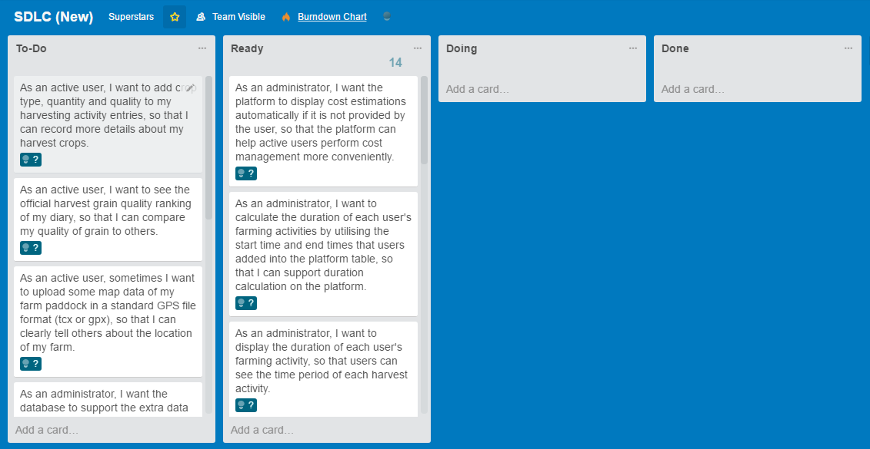

Figure : The SDLC board of Team Superstars, created on Trello, with the tasks contained in the first Sprint.

Story points were again decided with reference to task priority, complexity and uncertainty (CA Technologies, 2017). Some references from similar past projects were utilised, included one from the past experience of team members (Zheping, 2017).

The ‘To-Do’ lane contains tasks which need to be completed in order to develop some desired features for the software. The ‘Ready’ lane contains tasks which are ready to be allocated to members. The ‘Doing’ lane will contain tasks which are presently being undertaken. A member will allocate themselves to the task and move the card into that lane. Tasks will then be put into the ‘Done’ lane when they have been considered completed and have been reviewed by the team.

## 5.3 SDLC Team Velocity

The expected SDLC Sprint duration of the team was calculated for confirmation purposes by using a Burndown Chart. This was created by using the ‘expected’ story points on the cards, the result of which is as shown in Figure 7.

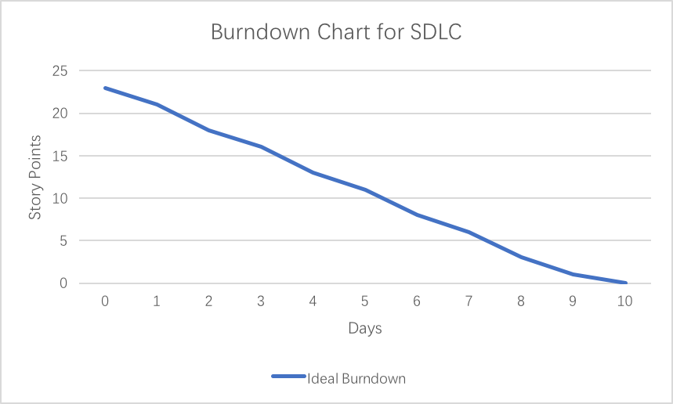

Figure : Burndown Chart of Team Superstars’ SDLC Sprint

From the above graph, it can be seen that approximately 23 story points can be completed in the Sprint of 10 days.

The Team Velocity in a single Sprint cycle can be calculated by adding up the number of Story Points the team can complete in a short iteration.

The Velocity of Team Superstars is predicted to be as follows:

**Week 1**: 12 story points/week

**Week 2**: 11 story points/week

## 5.4 Scope Creep

Burnup Charts track both completed work and total required work using two separate lines. It requires information about both the expected and actual story points of the tasks to be completed. Hence it can provide information about scope creep (Clarios Technology, 2016).

Scope creep occurs when work is added to or removed from a project, due to factors such as client requirements changes or project deadline limitations. An increase in the expected work line indicates that work has been added to the project.

Figure 8 shows an image of the expected Burnup Chart for Team Superstars’ first SDLC Sprint.

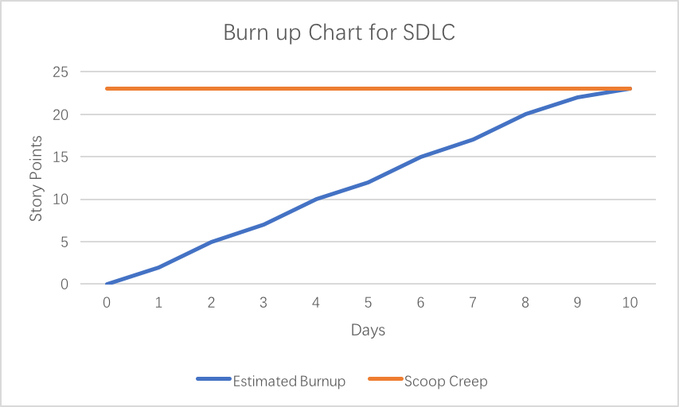

Figure : Burnup Chart of Team Superstars’ SDLC Sprint

As can be seen from the graph, the progress of the team is expected to be relatively consistent. Owing to the fact that the SDLC Sprint has not yet begun, only an expected scope line is added. It is important that scope creep is monitored throughout the duration of the project, as constant increases could jeopardise the team’s chance of completing tasks in time.

# Summary

A new farming social media platform is under development by Team Superstars through employing the Agile Scrum method. The development of the software was performed through the ‘envision’, ‘speculate’, ‘explore’, ‘adapt’ and ‘close’ phases. Currently, the first PMP Sprint of four weeks has been completed and the work is under review. The team plans to implement the first SDLC Sprint of two weeks to begin development of platform features.

It is considered that the project can be managed and monitored effectively through use of these short Sprints. The short timeframes ensure that problems are quickly discovered and progress can be constantly tracked.

In assigning the expected story points of each task in the Sprints, a Burndown Chart can be created to give an idea of the Team Velocity. It was found that the average for the team was 13 story points per week. This knowledge is utilised to plan upcoming Sprints. After finishing a sprint, a Burnup Chart can be produced to keep track of scope creep, which would further help in tracking the progress of the project.

# References

Alnaqaa, A. (2013, November 19). *Understanding Agile Project Management*. Retrieved from SlideShare: https://www.slideshare.net/ahmedalnaqaa/understanding-agile-project-management-apm-28424611

CA Technologies. (2017). *Sizing and Estimates Overview*. Retrieved from CA Technologies: https://help.rallydev.com/sizing-and-estimates-overview

Chandana. (2012). *Agile Certification Training: Agile Project Management Framework*. Retrieved from Simpli Learn: https://www.simplilearn.com/apm-framework-article

Clarios Technology. (2016). *Burn Up Vs Burn Down Chart*. Retrieved from Clarios Technology: http://www.clariostechnology.com/productivity/blog/burnupvsburndownchart

Cohn, M. (2016). *What are Story Points*. Retrieved from Mountain Goat Software: https://www.mountaingoatsoftware.com/blog/what-are-story-points

Haughton, B. (2011). *Agile Scrum Sprint Length: What's Right for You*. Retrieved from Methods and Tools: http://www.methodsandtools.com/archive/scrumspringlength.phpM

Highsmith, J. (2009). *Agile Project Management: Creating Innovative Products.* Addison-Wesley Professional.

Mittal, N. (2013, August 7). *The Burn-Down Chart*. Retrieved from Scrum Alliance: https://www.scrumalliance.org/community/articles/2013/august/burn-down-chart-%E2%80%93-an-effective-planning-and-tracki

Waters, K. (2007, September 28). *How to Estimate Your Product Backlog*. Retrieved from All About Agile: http://www.allaboutagile.com/how-to-implement-scrum-in-10-easy-steps-step-2-how-to-estimate-your-product-backlog/

Zheping, L. (2017). *Distributed System Project*. Retrieved from GitHub: https://github.com/zhepingLiu/Distributed-System-Project

# Appendix A

**Team** *Superstars* **Agenda**

**Date:** *10/04/17*

1. Introduction
2. Nomination of Scrum Master
3. Meeting Tasks
   1. Decide on team name
   2. Establish team norms
   3. Decide on risk register
4. Planned upcoming tasks

Meeting #1 Minutes

Meeting of: Superstars

Held at: Alice Hoy 108

Date: 10/04/17

From: 2:15pm - 3:15pm

Opening:

The regular meeting of the Superstars was opened at 2:15pm on 10/04/17 in Alice Hoy by Lilian Chan.

Present:

Kuan Qian, Sheng Wu, Zheping Liu, Ao Li, Lilian Chan

Approval of agenda:

The agenda was unanimously approved as distributed.

Minutes

Discussion of high-level requirements

The minutes of the previous meeting were unanimously approved as distributed.

|  |  |  |
| --- | --- | --- |
| Project Plan: Week 7, Date 10/04/2017 | | |
| **Task** | **Resources** | **Estimated Time** |
| Decide on team name | All | 5 hours |
| Establish team norms | All | 5 hours |
| Decide risk register | All | 5 hours |

Next meeting

The next general meeting will be at 1PM on 24/04/17 at Alice Hoy 108.

Minutes submitted by: Lilian Chan

Approved by: All

Meeting #2 Minutes

Meeting of: Superstars

Held at: Alice Hoy 108

Date: 24th, April, 2017

From: 1pm – 2.15pm

Opening:

The regular meeting of the Superstars was opened at 1pm on 24th, April, 2017 in Alice Hoy 108 by Sheng Wu.

Present:

Sheng Wu, Lilian Chan, Ao Li, Kuan Qian, Zheping Liu

Approval of agenda:

The agenda was unanimously approved as distributed.

Approval of minutes

The minutes of the previous meeting were unanimously approved as distributed.

|  |  |  |  |  |  |
| --- | --- | --- | --- | --- | --- |
| Previous Project Plan: Week 7, Date 10/04/2017 | | | | | |
| **Task** | **Resources** | **Estimated Time** | **Actual Time** | **Completed** | **Comment** |
| Decide on team name | All | 5 hours | 5 hours | yes | All good |
| Establish team norms | All | 5 hours | 5 hours | yes | A lot of confusion but finally organized |
| Decide risk register | All | 5 hour | 5 hour | yes | All good |

|  |  |  |
| --- | --- | --- |
| Project Plan: Week 8, Date 24/04/2017 | | |
| **Task** | **Resources** | **Estimated Time** |
| Define desired features (epic user stories) | Ao  Kuan | 5 hours  5 hours |
| Estimate effort and assign story points | Lilian  Sheng | 4 hours  3 hours |
| Write solution overview draft | Zheping | 5 hours |

Next meeting

The next general meeting will be at 1pm on 1st May, 2017 at Alice Hoy 108.

Minutes submitted by: Sheng Wu

Approved by: All

Meeting #3 Minutes

Meeting of: Superstars

Held at: Alice Hoy 109

Date: 01/05/17

From: 1:15pm – 2:15pm

Opening:

The regular meeting of the Superstars was opened at 1:15pm on 01/05/17 in Alice Hoy by Ao Li.

Present:

Kuan Qian, Sheng Wu, Zheping Liu, Ao Li, Lilian Chan

Approval of agenda:

The agenda was unanimously approved as distributed.

Approval of minutes

The minutes of the previous meeting were unanimously approved as distributed.

|  |  |  |  |  |  |
| --- | --- | --- | --- | --- | --- |
| Previous Project Plan: Week 8, Date 24/04/2017 | | | | | |
| **Task** | **Resources** | **Estimated Time** | **Actual Time** | **Completed** | **Comment** |
| Define desired features (epic user stories) | Ao,  Kuan | 5 hours  5 hours | 5 hours  5 hours | yes | All good |
| Estimate effort and assign story points | Lilian  Sheng | 4 hours  3 hours | 4 hours  3 hours | yes | All good |
| Write solution overview draft | Zheping | 5 hours | 5 hours | yes | Need to do some small modification. |

|  |  |  |
| --- | --- | --- |
| Project Plan: Week 9, Date 01/05/17 | | |
| **Task** | **Resources** | **Estimated Time** |
| Review survey from clients | All (exc. Ao) | 5 hours |
| Evaluate and rank features | All (exc. Ao) | 5 hours |
| Groom product backlog | Ao | 5 hours |

Next meeting

The next general meeting will be at 1:15pm on 08/05/17 at Alice Hoy 108.

Minutes submitted by: Ao Li

Approved by: All

Meeting #4 Minutes

Meeting of: Superstars

Held at: Alice Hoy 109

Date: 08/05/17

From: 1:15pm – 2:15pm

Opening:

The regular meeting of the Superstars was opened at 1:15pm on 08/05/17 in Alice Hoy by Zheping Liu.

Present:

Qian Kuan, Sheng Wu, Zheping Liu, Ao Li, Lilian Chan

Approval of agenda:

The agenda was unanimously approved as distributed.

Approval of minutes

The minutes of the previous meeting were unanimously approved as distributed.

|  |  |  |  |  |  |
| --- | --- | --- | --- | --- | --- |
| Previous Project Plan: Week 9, Date 01/05/17 | | | | | |
| **Task** | **Resources** | **Estimated Time** | **Actual Time** | **Completed** | **Comment** |
| Review survey from clients | All (exc. Ao) | 5 hours | 5 hours | yes | All good |
| Evaluate and rank features | All (exc. Ao) | 5 hours | 5 hours | yes | All good |
| Groom product backlog | Ao | 5 hours | 8 hours | yes | All good |

|  |  |  |
| --- | --- | --- |
| Project Plan: Week 10, Date 08/05/17 | | |
| **Task** | **Resources** | **Estimated Time** |
| Review business objectives | Kuan | 3 hours |
| Select features to be released and provide reasoning | All | 3 hours |
| Create sprint backlog | Sheng | 5 hours |
| Plan features to be released | All | 5 hours |

Next meeting

The next general meeting will be at 1:15pm on 15/05/17 at Alice Hoy 108.

Minutes submitted by: Zheping Liu

Approved by: All

Meeting #5 Minutes

Meeting of: Superstars

Held at: ERC Lower Ground Floor

Date: 16/05/17

From: 6:15pm – 7:15pm

Opening:

The regular meeting of the Superstars was opened at 6:15pm on 16/05/17 in ERC by Kuan Qian.

Present:

Kuan Qian, Sheng Wu, Zheping Liu, Ao Li, Lilian Chan

Approval of agenda:

The agenda was unanimously approved as distributed.

Approval of minutes

The minutes of the previous meeting were unanimously approved as distributed.

|  |  |  |  |  |  |
| --- | --- | --- | --- | --- | --- |
| Previous Project Plan: Week 10, Date 08/05/17 | | | | | |
| **Task** | **Resources** | **Estimated Time** | **Actual Time** | **Completed** | **Comment** |
| Review business objectives | Kuan | 3 hours | 3 hours | yes | All good |
| Select features to be released and provide reasoning | Sheng | 5 hours | 5 hours | yes | All good |
| Create sprint backlog | All | 5 hours | 5 hours | yes | All good |
| Plan features to be released | All | 5 hours | 5 hours | yes | All good |

|  |  |  |
| --- | --- | --- |
| Project Plan: Week 11, Date 16/05/17 | | |
| **Task** | **Resources** | **Estimated Time** |
| Verify accuracy of estimates | All | 5 hours |
| Plan feature completion dates | Sheng | 2 hours |
| Plan feature implementation dates | All | 1 hour |
| Document risks by feature | All | 5 hours |
| Review effort estimations(PMP) | All | 5 hours |
| Monitor team velocity(PMP) | Ao | 1 hour |
| Review effort estimations(SDLC) | Zheping | 2 hours |
| Predict team velocity(SDLC) | Ao | 1 hour |
| Monitor scope creep | All | 5 hours |

Next meeting

There is no further meeting planned.

# Appendix B

Timesheet 1

Member Name: Ao Li

Team name: Superstars

Tutor: William Tio

Date: 03/04/2017

|  |  |  |  |
| --- | --- | --- | --- |
| **Date** | **Activity** | **Planned** | **Actual** |
| Monday 03 April | Reading Assignment spec and case study | 1 hour | 1 hour |
| Wednesday 05 April | Define project charters | 1 hour | 1 hour |
| Monday 10 April | Attend meeting 1 | 1 hour | 1 hour |
| Wednesday 12 April | Thought our team name | 1 hour | 1 hour |
| Monday 17 April | Establish team norms | 1 hour | 1 hour |
| Thursday 20 April | Decide risk register | 1 hour | 1 hour |
| Monday 24 April | Attend meeting 2 | 1 hour | 1 hour |
| Friday 28 April | Define desired features (epic user story) | 5 hours | 5 hours |
| Monday 01 May | Attend meeting 3 | 1 hour | 1 hour |
| Friday 05 May | Groom product backlog | 5 hours | 8 hours |
| Monday 08 May | Attend meeting 4 | 1 hour | 1 hour |
| Wednesday 10 May | Select release features and provide reasoning | 1 hour | 1 hour |
| Friday 12 May | Plan features to be released | 1 hour | 1 hour |
| Tuesday 16 May | Attend meeting 5 | 1 hour | 1 hour |
| Tuesday 16 May | Verify accuracy of estimates | 1 hour | 1 hour |
| Tuesday 16 May | Plan feature implementation dates | 1 hour | 1 hour |
| Wednesday 17 May | Document risks by feature | 1 hour | 1 hour |
| Wednesday 17 May | Review effort estimations(PMP) | 1 hour | 1 hour |
| Thursday 18 May | Monitor team velocity(PMP) | 1 hour | 1 hour |
| Friday 19 May | Document risks by feature | 1 hour | 1 hour |
| Friday 19 May | Review effort estimations(PMP) | 1 hour | 1 hour |
| Monday 22 May | Reduce risks and uncertainties | 1 hour | 1 hour |

Timesheet 2

*Member Name: Kuan Qian*

*Team name: Superstars*

*Tutor: Rahul Sharma*

*Date: 03/04/2017*

|  |  |  |  |
| --- | --- | --- | --- |
| **Date** | **Activity** | **Planned** | **Actual** |
| Wednesday 05 April | Reading the specification and documents | 1 hour | 1 hour |
| Friday 07 April | Confirm project too set | 1 hour | 1 hour |
| Monday 10 April | Attend meeting 1 | 1 hour | 1 hour |
| Monday 17 April | Establish team norms | 1 hour | 1 hour |
| Wednesday 12 April | Thought our team name | 1 hour | 1 hour |
| Thursday 20 April | Decide risk register | 1 hour | 1 hour |
| Monday 24 April | Attend meeting 2 | 1 hour | 1 hour |
| Friday 28 April | Define desired features (epic user story) | 5 hours | 5 hours |
| Monday 01 May | Attend meeting 3 | 1 hour | 1 hour |
| Wednesday 03 May | Review survey from clients | 1 hour | 1 hour |
| Friday 05 May | Evaluate and rank features | 1 hour | 1 hour |
| Monday 08 May | Attend meeting 4 | 1 hour | 1 hour |
| Wednesday 10 May | Select features to be released and provide reasoning | 1 hour | 1 hour |
| Friday 12 May | Review business objectives | 3 hours | 3 hours |
| Friday 12 May | Plan features to be released | 1 hour | 1 hour |
| Tuesday 16 May | Attend meeting 5 | 1 hour | 1 hour |
| Tuesday 16 May | Verify accuracy of estimates | 1 hour | 1 hour |
| Tuesday 16 May | Plan feature implementation dates | 1 hour | 1 hour |
| Wednesday 17 May | Document risks by feature | 1 hour | 1 hour |
| Friday 19 May | Review effort estimations(PMP) | 1 hour | 1 hour |
| Friday 19 May | Monitor scope creep | 1 hour | 1 hour |

Timesheet 3

*Member Name: Zheping Liu*

*Team name: Superstars*

*Tutor: Rahul Sharma*

*Date: 03/04/2017*

|  |  |  |  |
| --- | --- | --- | --- |
| **Date** | **Activity** | **Planned** | **Actual** |
| Monday 03 April | Reading Assignment spec and case study | 1 hour | 1 hour |
| Thursday 06 April | Determine project community | 1 hour | 1 hour |
| Monday 10 April | Attend meeting 1 | 1 hour | 1 hour |
| Wednesday 12 April | Thought our team name | 1 hour | 1 hour |
| Monday 17 April | Establish team norms | 1 hour | 1 hour |
| Thursday 20 April | Decide risk register | 1 hour | 1 hour |
| Monday 24 April | Attend meeting 2 | 1 hour | 1 hour |
| Thursday 27 April | Write solution overview draft | 5 hours | 5 hours |
| Monday 01 May | Attend meeting 3 | 1 hour | 1 hour |
| Friday 05 May | Review survey from clients | 1 hour | 1 hour |
| Saturday 06 May | Evaluate and rank features | 1 hour | 1 hour |
| Monday 08 May | Attend meeting 4 | 1 hour | 1 hour |
| Thursday 11 May | Select release features and provide reasoning | 1 hour | 1 hour |
| Friday 12 May | Plan features to be released | 1 hour | 1 hour |
| Thusday 16 May | Attend meeting 5 | 1 hour | 1 hour |
| Tuesday 16 May | Verify accuracy of estimates | 1 hour | 1 hour |
| Wednesday 17 May | Plan feature completion dates | 1 hour | 1 hour |
| Thursday 18 May | Review effort estimations(SDLC) | 2 hour | 2 hour |
| Friday 19 May | Document risks by feature | 1 hour | 1 hour |
| Friday 19 May | Review effort estimations(PMP) | 1 hour | 1 hour |
| Saturday 20 May | Monitor scope creep | 1 hour | 1 hour |
| Monday 22 May | Testing features | 1 hour | 1 hour |

Timesheet 4

*Member Name: Sheng Wu*

*Team name: Superstars*

*Tutor: William Tio*

*Date: 03/04/2017*

|  |  |  |  |
| --- | --- | --- | --- |
| **Date** | **Activity** | **Planned** | **Actual** |
| Tuesday 04 April | Define project expectations | 1 hour | 1 hour |
| Sunday 09 April | Read Assignment spec and case study | 1 hour | 1 hour |
| Monday 10 April | Attend meeting 1 | 1 hour | 1 hour |
| Wednesday 12 April | Thought our team name | 1 hour | 1 hour |
| Monday 17 April | Establish team norms | 1 hour | 1 hour |
| Thursday 20 April | Decide risk register | 1 hour | 1 hour |
| Friday 21 April | Gather feature | 1 hour | 1 hour |
| Monday 24 April | Attend meeting 2 | 1 hour | 1 hour |
| Tuesday 25 April | Estimate effort and assign story points | 3 hours | 3 hours |
| Monday 1 May | Attend meeting 3 | 1 hour | 1 hour |
| Wednesday 03 May | Review survey from clients | 1 hour | 1 hour |
| Friday 05 May | Evaluate and rank features | 1 hour | 1 hour |
| Monday 8 May | Attend meeting 4 | 1 hour | 1 hour |
| Tuesday 9 May | Reason what features to be released | 1 hour | 1hour |
| Wednesday 10 May | Create Sprint Backlog | 5 hours | 5 hours |
| Friday 12 May | Plan features to be released | 1 hour | 1 hour |
| Tuesday 16 May | Attend meeting 5 | 1 hour | 1 hour |
| Wednesday 17 May | Find support to back estimate of story points (SDLC) | 1 hour | 1 hour |
| Thursday 18 May | Plan completion and implementation dates | 3 hours | 3 hours |
| Friday 19 May | Document risks by feature | 1 hour | 1 hour |
| Friday 19 May | Review effort estimations(PMP) | 1 hour | 1 hour |
| Friday 19 May | Monitor scope creep | 1 hour | 1 hour |
| Friday 19 May | Create Brunup and Burndown chart | 1 hour | 1 hour |

Timesheet 5

Member Name: Lilian Chan

Team name: Superstars

Tutor: William Tio

Date: 03/04/2017

|  |  |  |  |
| --- | --- | --- | --- |
| **Date** | **Activity** | **Planned** | **Actual** |
| Monday 03 April | Reading assignment spec and case study | 1 hour | 1 hour |
| Monday 10 April | Attend meeting 1 | 1 hour | 1 hour |
| Wednesday 12 April | Defining team name | 1 hour | 1 hour |
| Monday 17 April | Establish team norms | 1 hour | 1 hour |
| Thursday 20 April | Decide the risk register | 1 hour | 1 hour |
| Monday 24 April | Attend meeting 2 | 1 hour | 1 hour |
| Sunday 28 April | Estimate effort required and assign story points | 4 hours | 4 hours |
| Monday 01 May | Attend meeting 3 | 1 hour | 1 hour |
| Wednesday 03 May | Review client survey responses | 1 hour | 1 hour |
| Thursday 04 May | Evaluate and rank features | 1 hour | 1 hour |
| Monday 08 May | Attend meeting 4 | 1 hour | 1 hour |
| Wednesday 10 May | Select release features and provide reasoning | 1 hour | 1 hour |
| Friday 12 May | Plan features to be released | 1 hour | 1 hour |
| Tuesday 16 May | Attend meeting 5 | 1 hour | 1 hour |
| Tuesday 16 May | Verify accuracy of estimates | 1 hour | 1 hour |
| Tuesday 16 May | Plan feature implementation dates | 1 hour | 1 hour |
| Wednesday 17 May | Document risks by feature | 1 hour | 1 hour |
| Wednesday 17 May | Review effort estimations (PMP) | 1 hour | 1 hour |
| Thursday 18 May | Monitor scope creep | 1 hour | 1 hour |